**STEP 1 : Select Storage from category and choose S3 (Scalable Storage in the Cloud)**

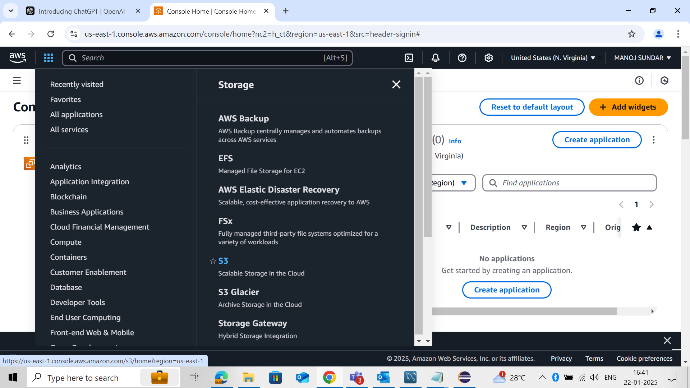

**STEP 2 : Create Bucket**

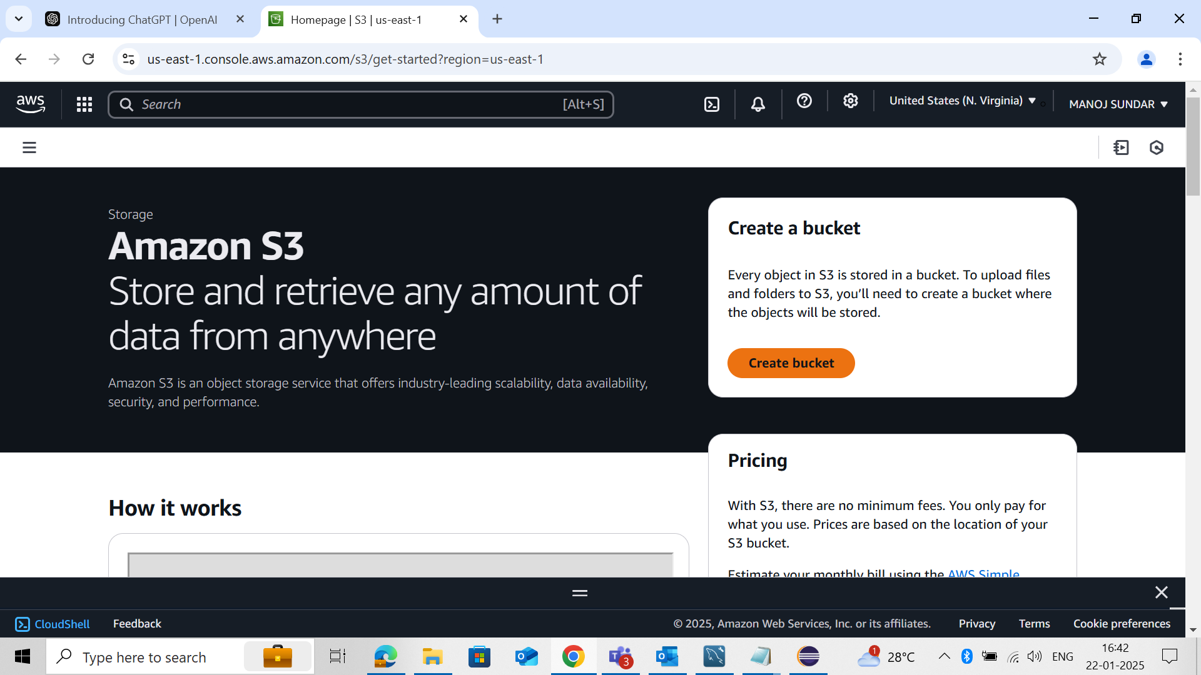

**STEP 3 : Create Bucket Name**

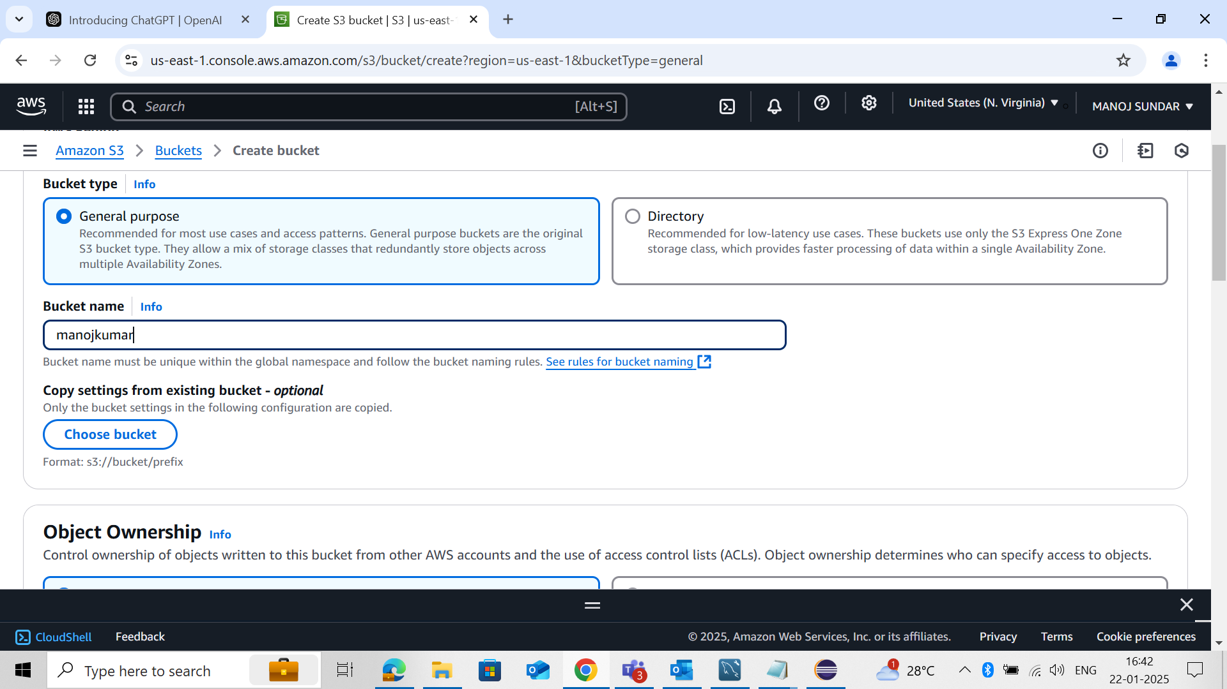

**STEP 4 : Remove Block all Public access**

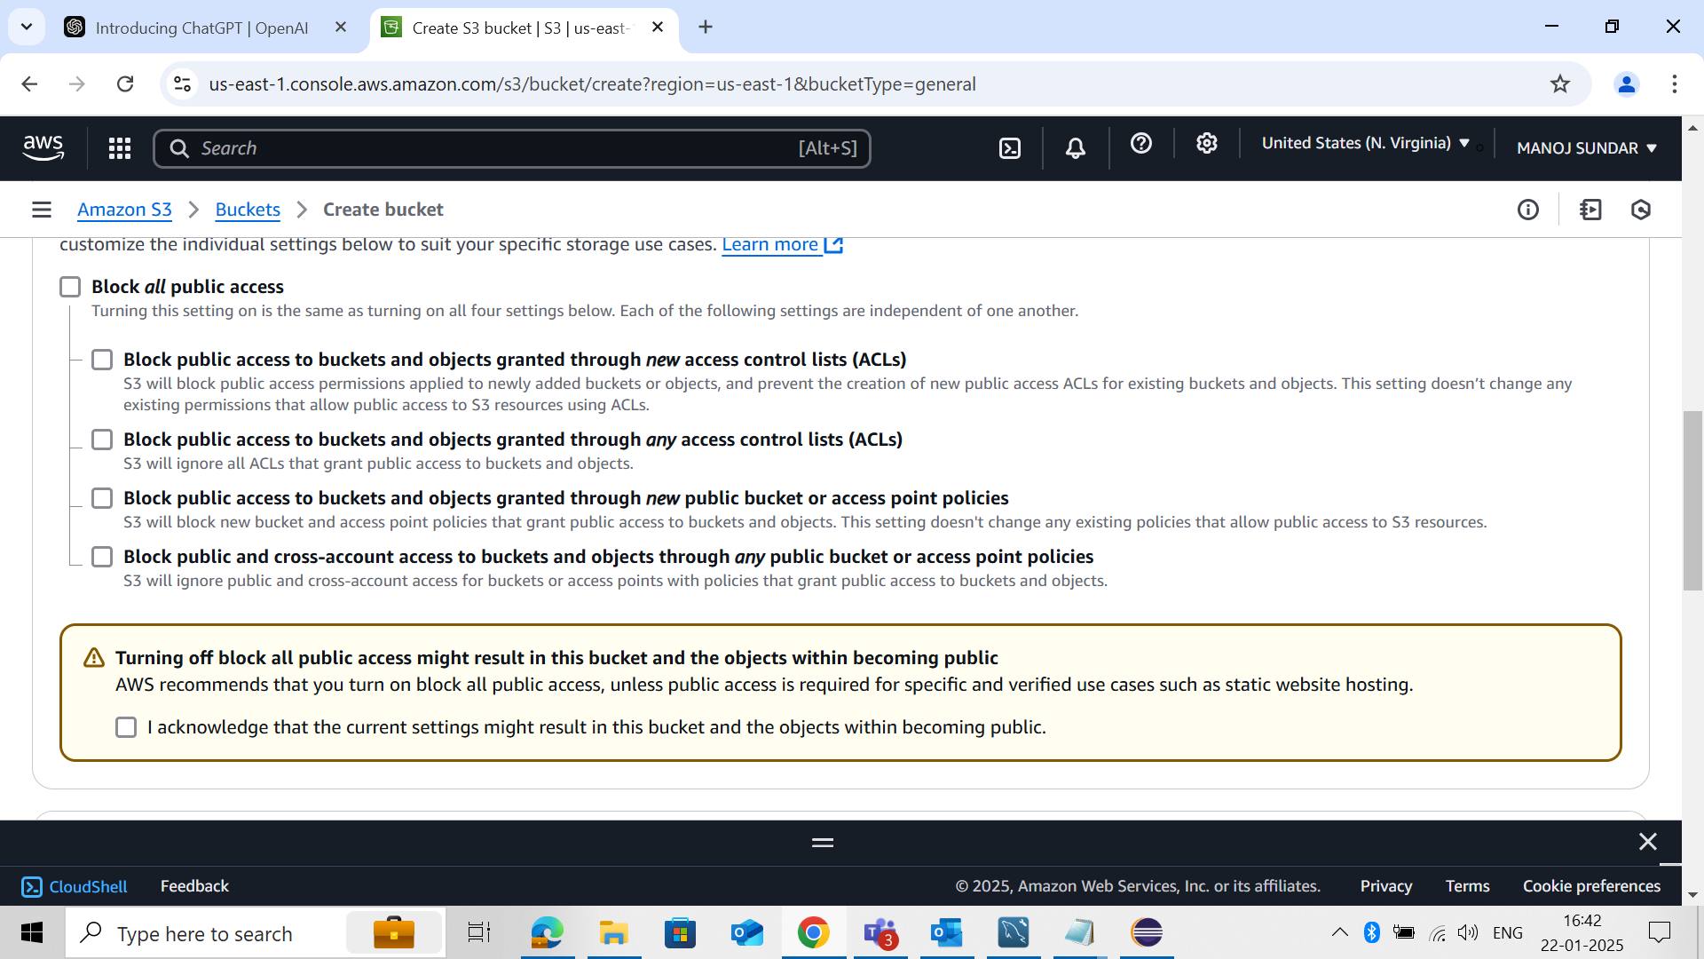

**STEP 5 : Enable Bucket Versioning**

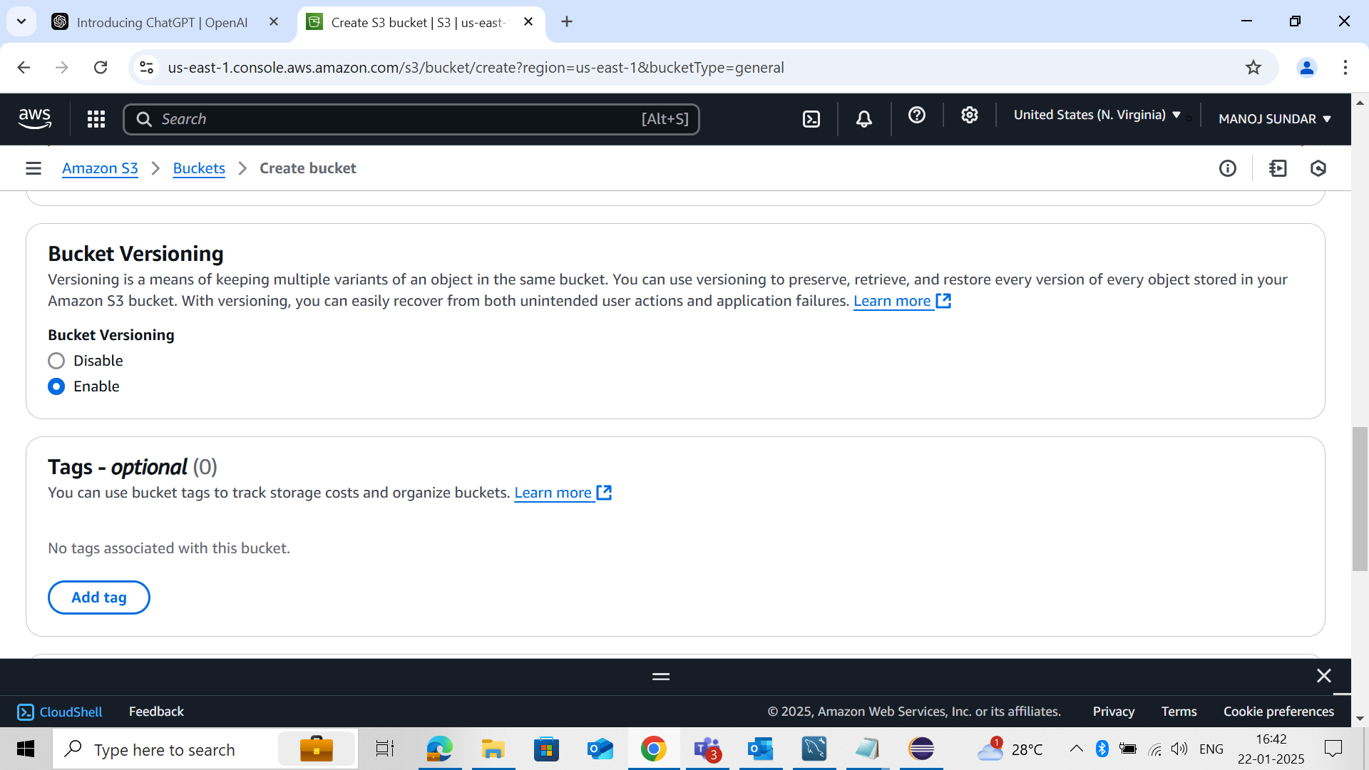

**STEP 6 : Click Create Bucket**

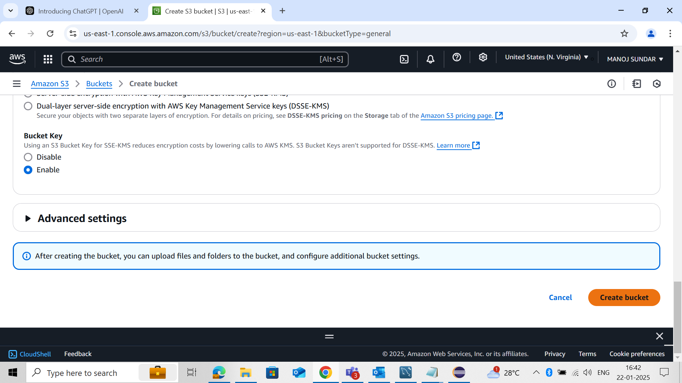

**STEP 7 : Bucket Create Successfully**

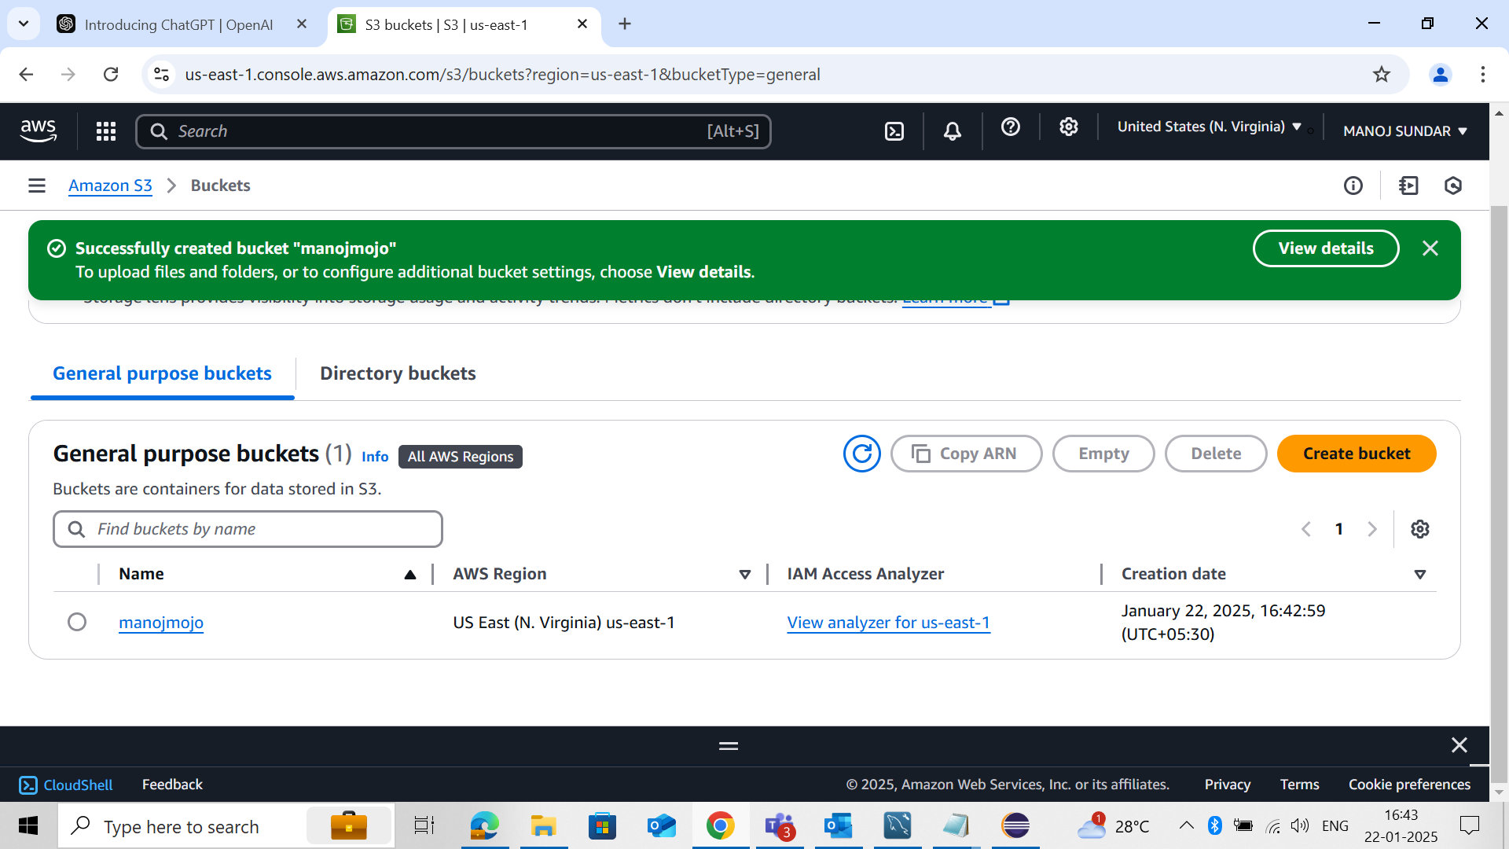

**STEP 8 : Upload used to upload any objects in this bucket**

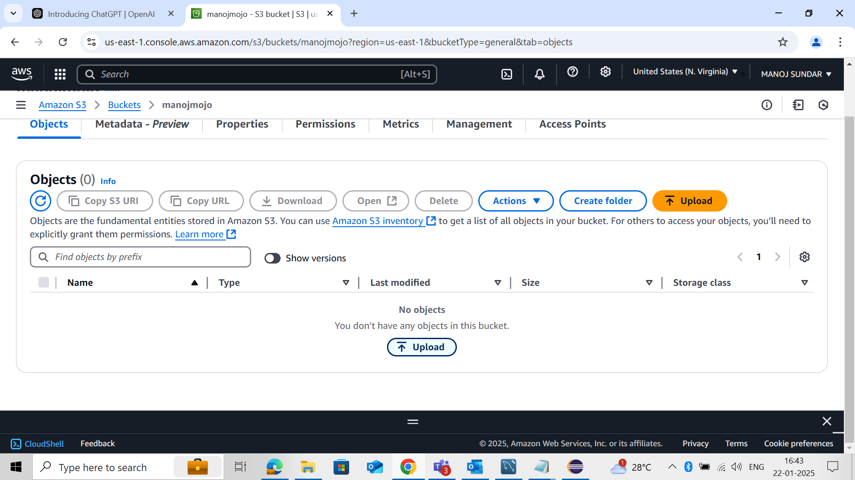

**STEP 9 :Choose Add files and upload file**

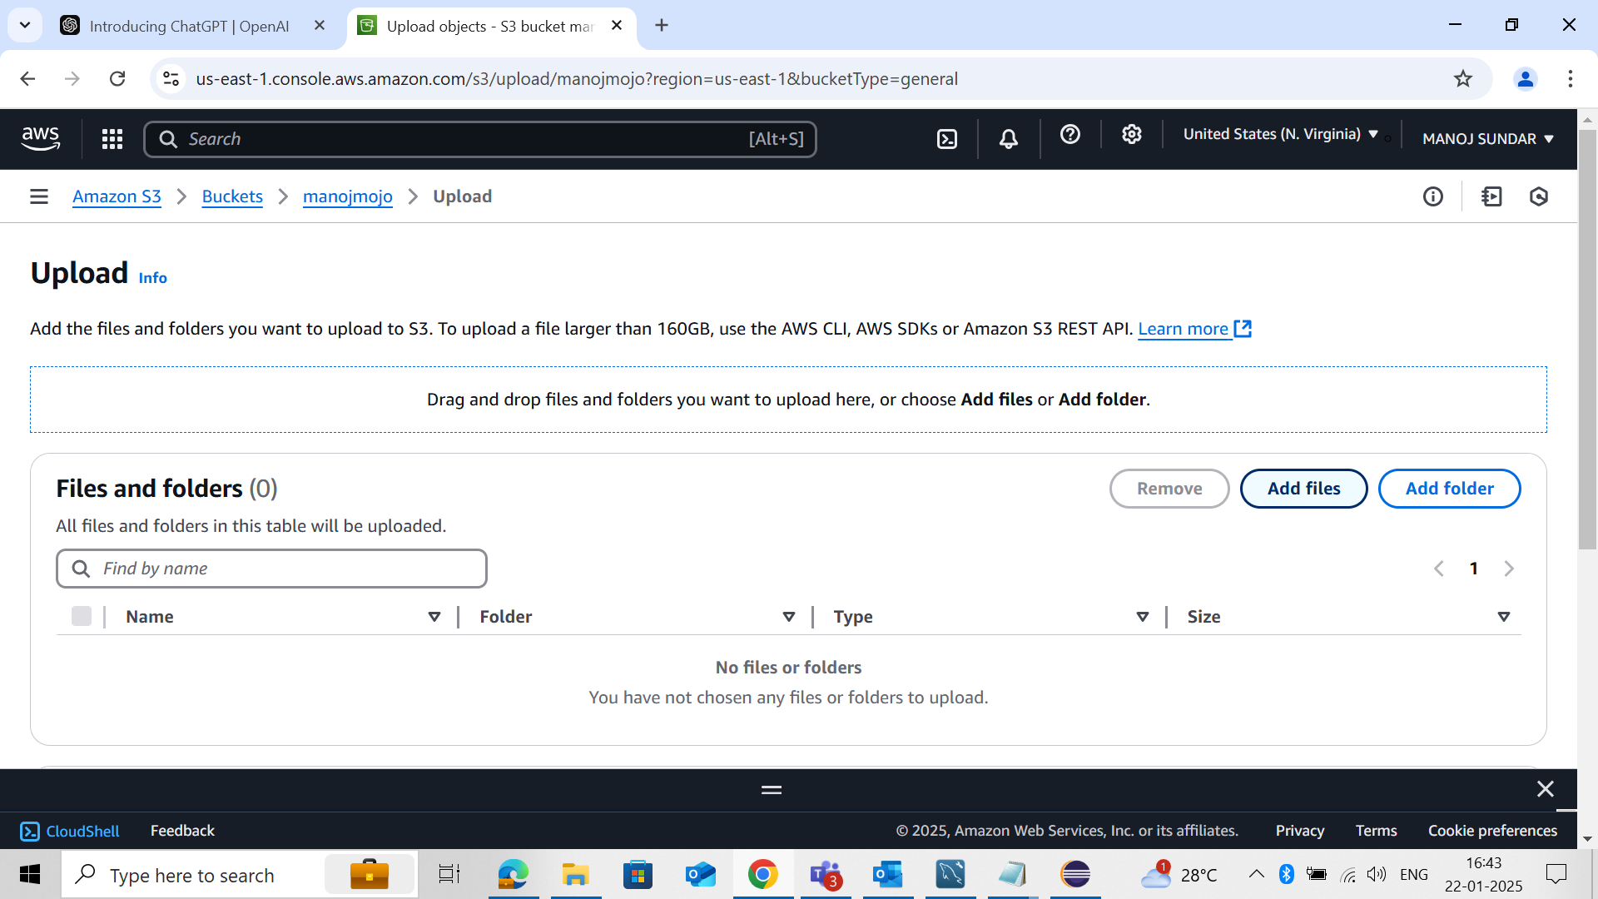

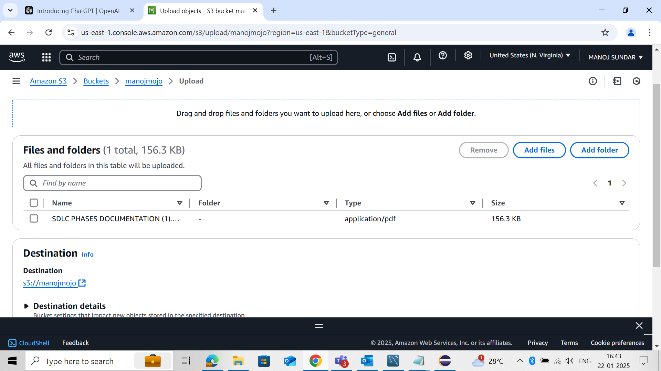

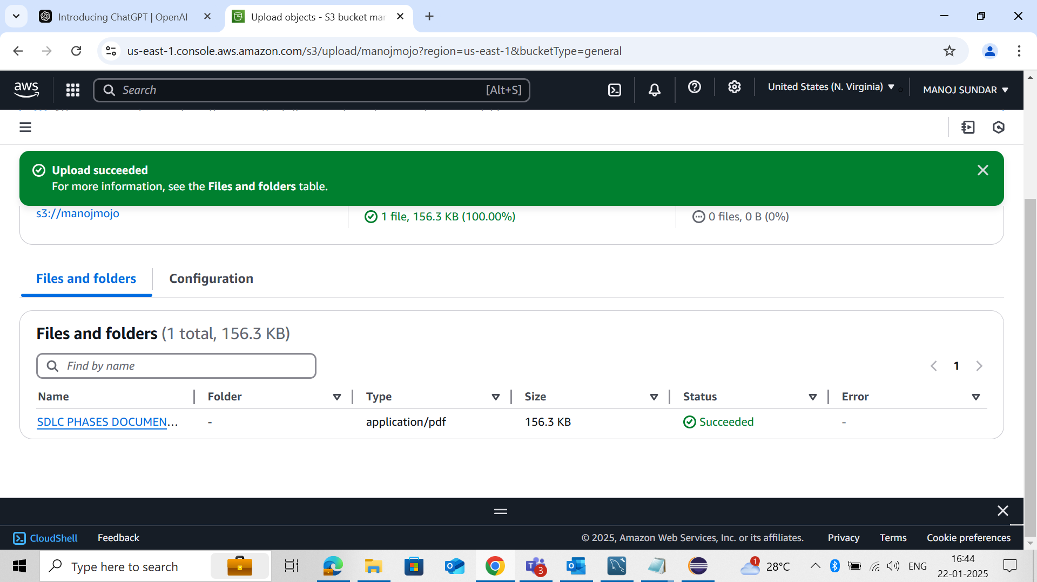

**STEP 10 : In Amazon S3 > Buckets > manojmojo(name) click Management**

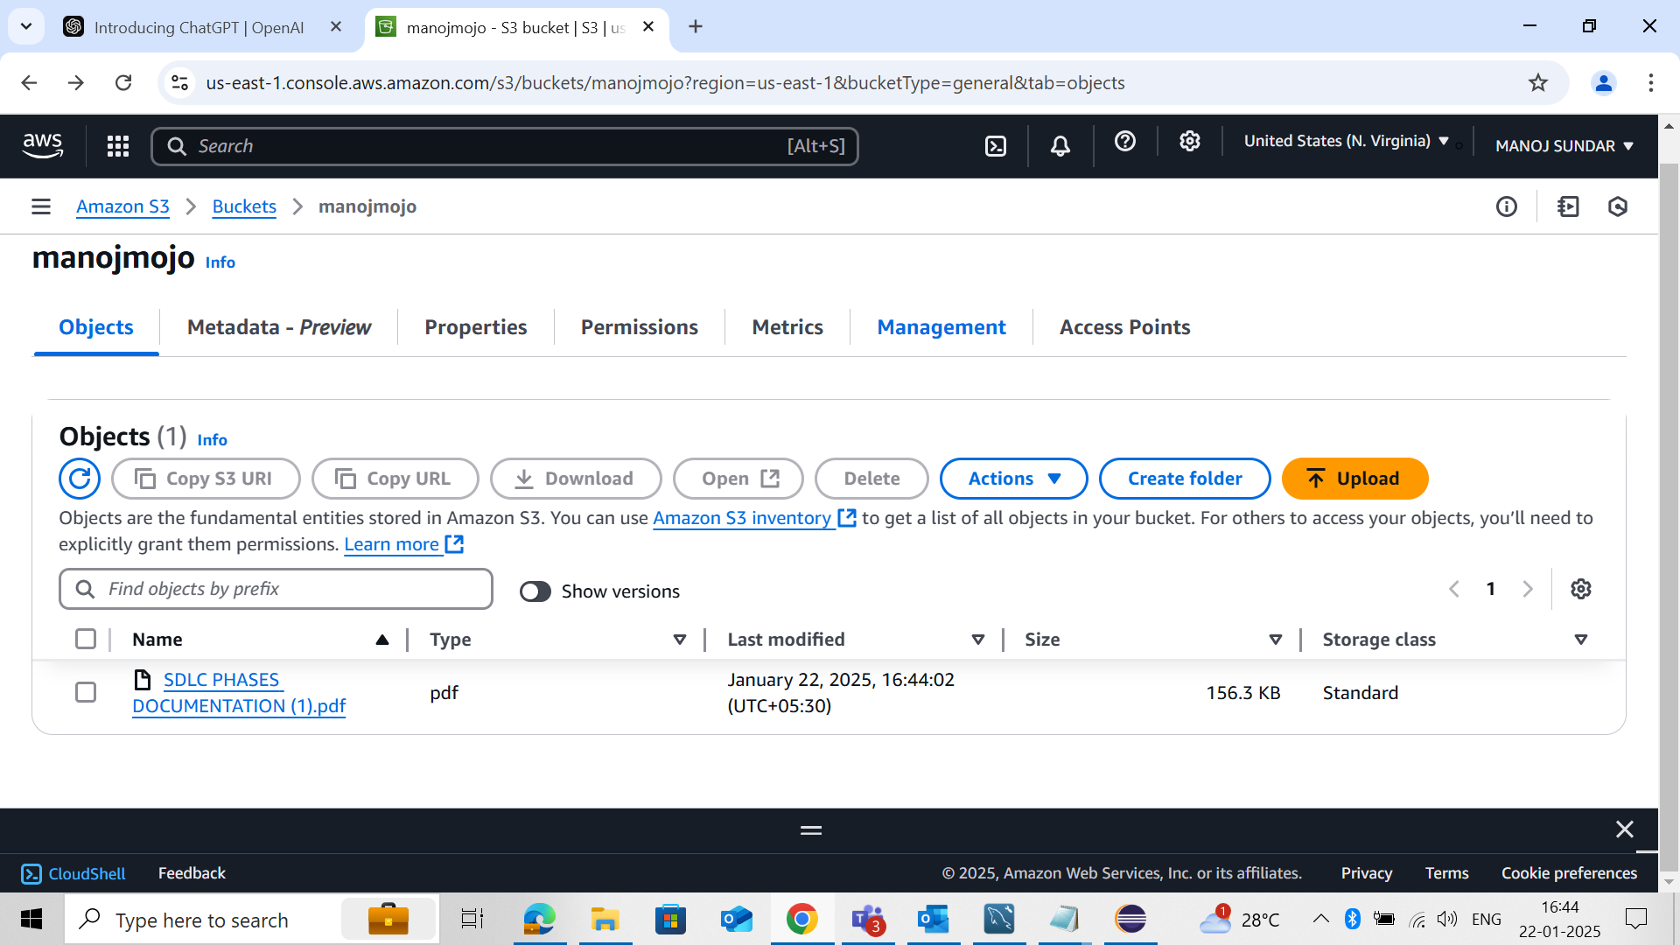

**STEP 11 : Create Lifecycle**

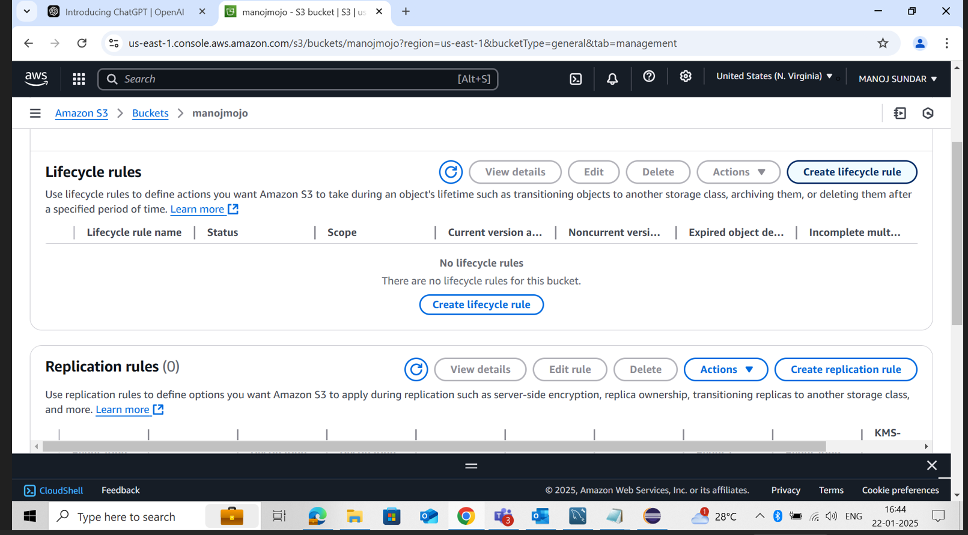

**STEP 12 : Create Lifecycle rule name and Prefix**

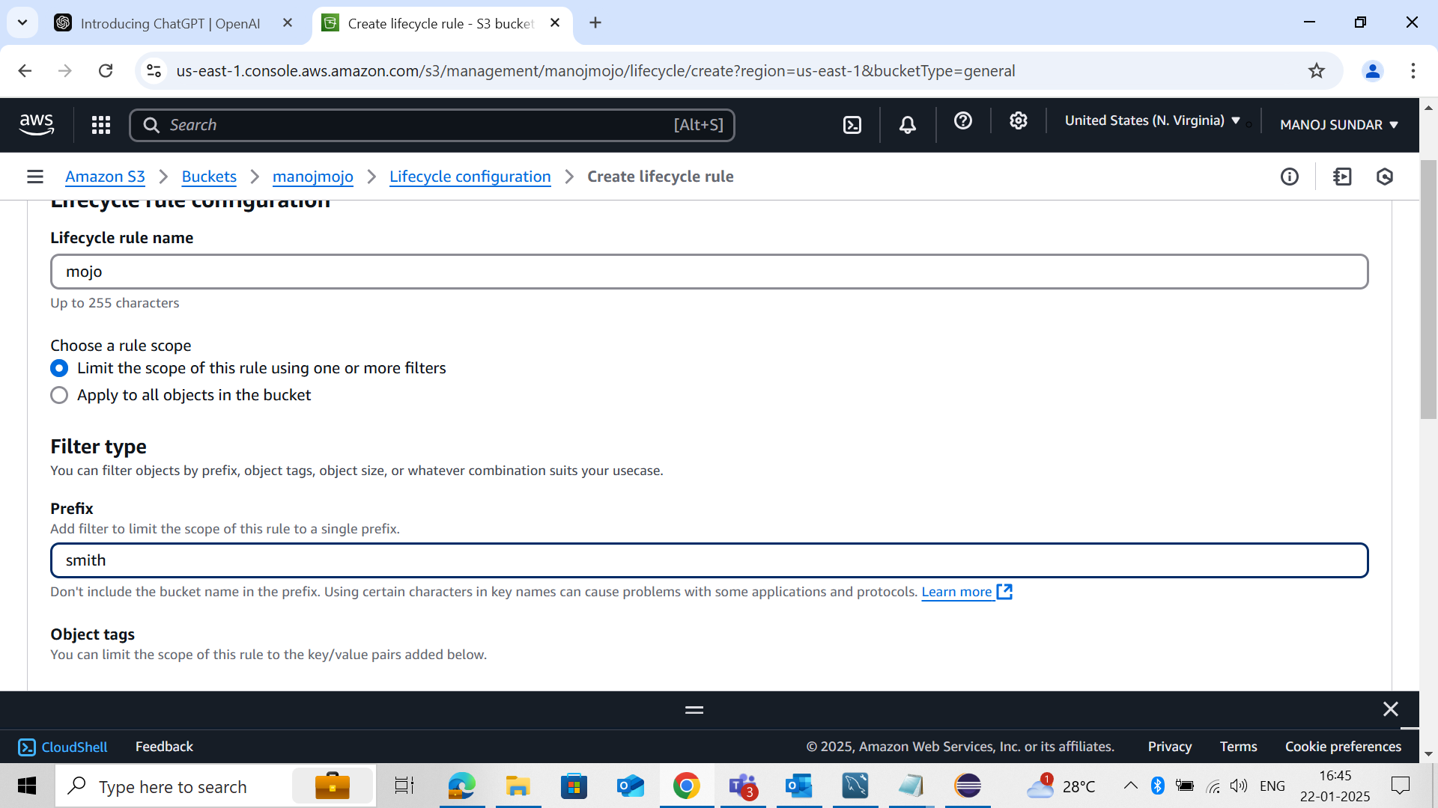

**STEP 13 : Select Lifecycle rule Action**

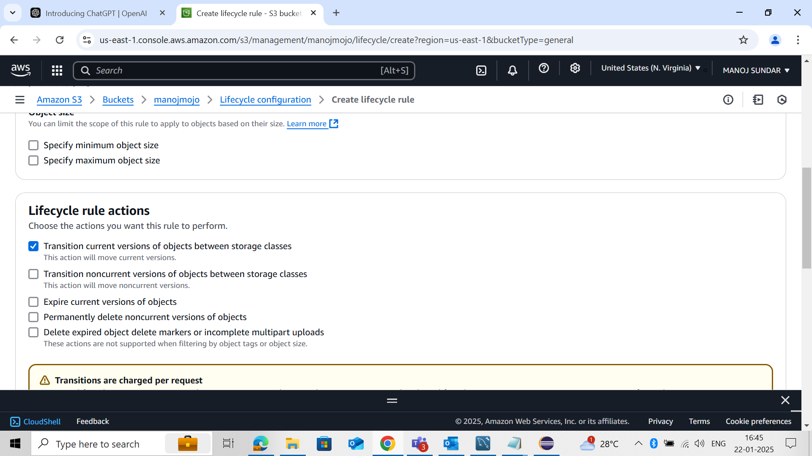

**STEP 14 : Select Days object Creation**

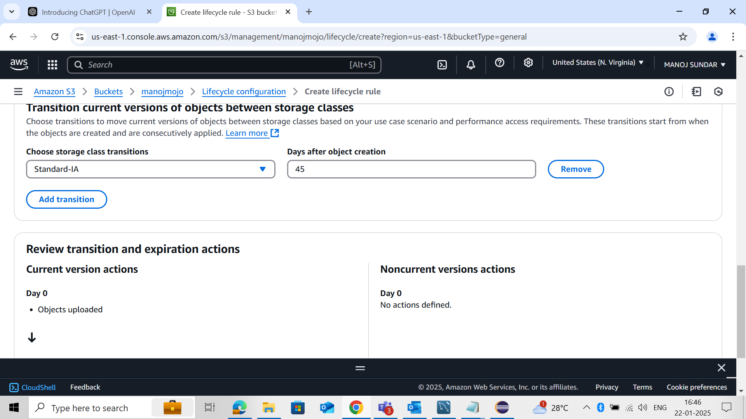

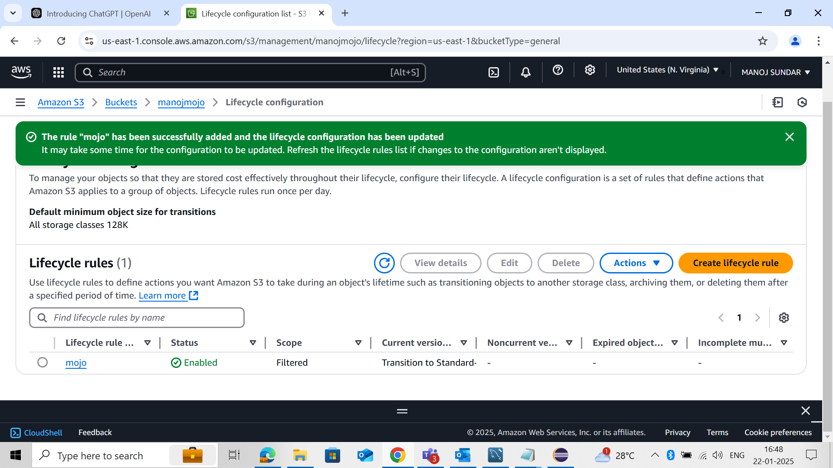

**STEP 15 : Copy Link and paste in URL**

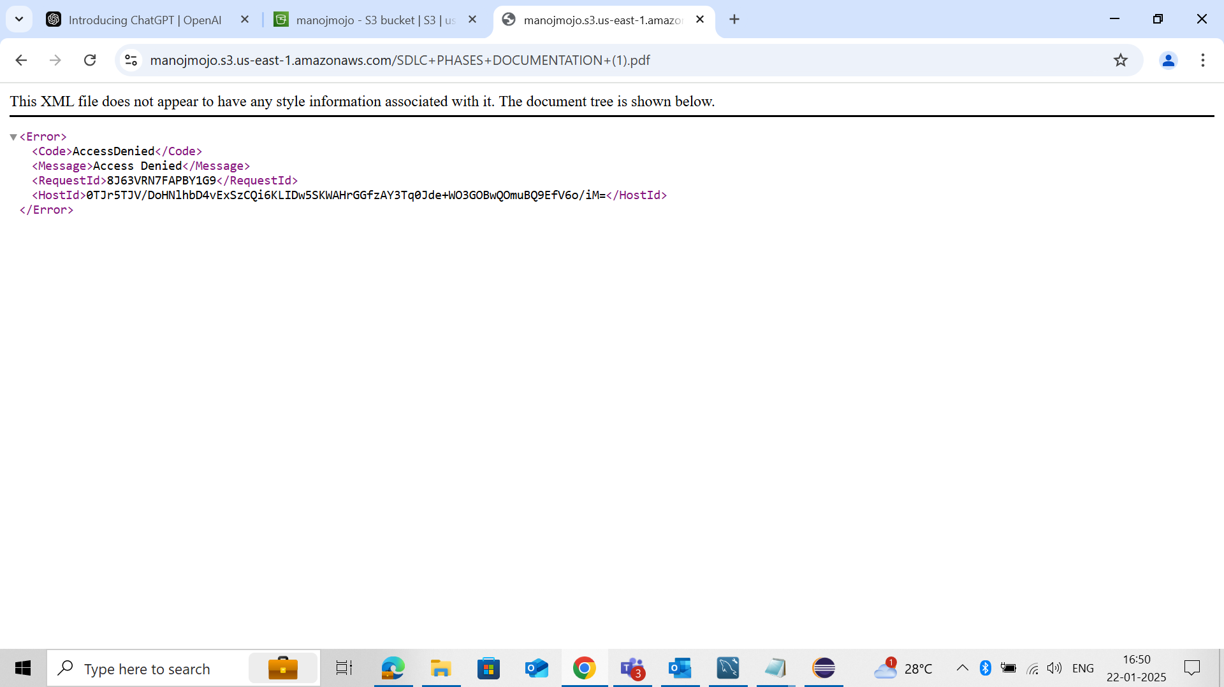

**STEP 16 : Set Time Interval**

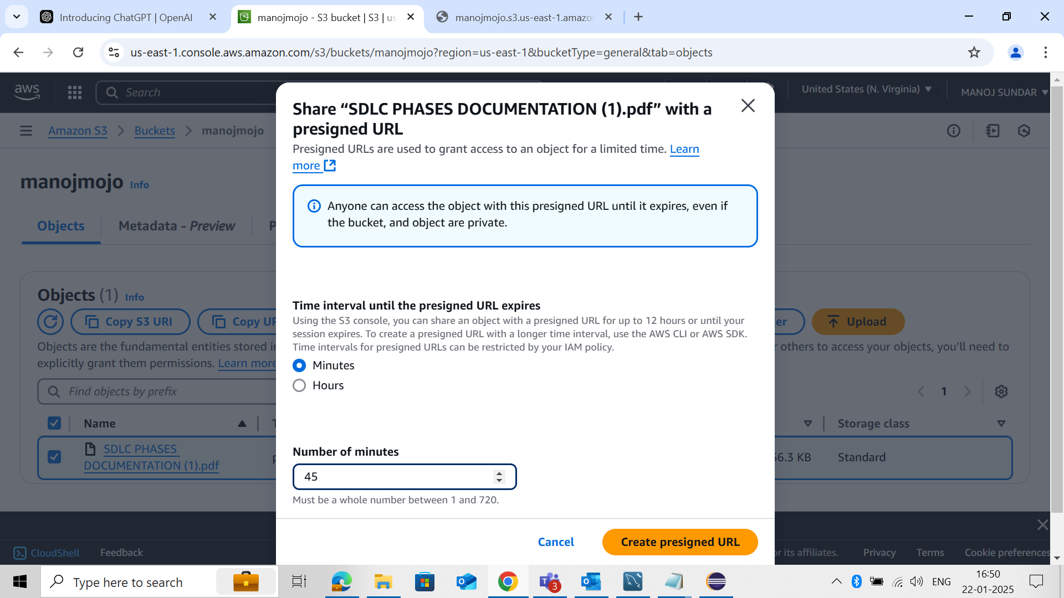

**STEP 17 :Copy presigned URL**

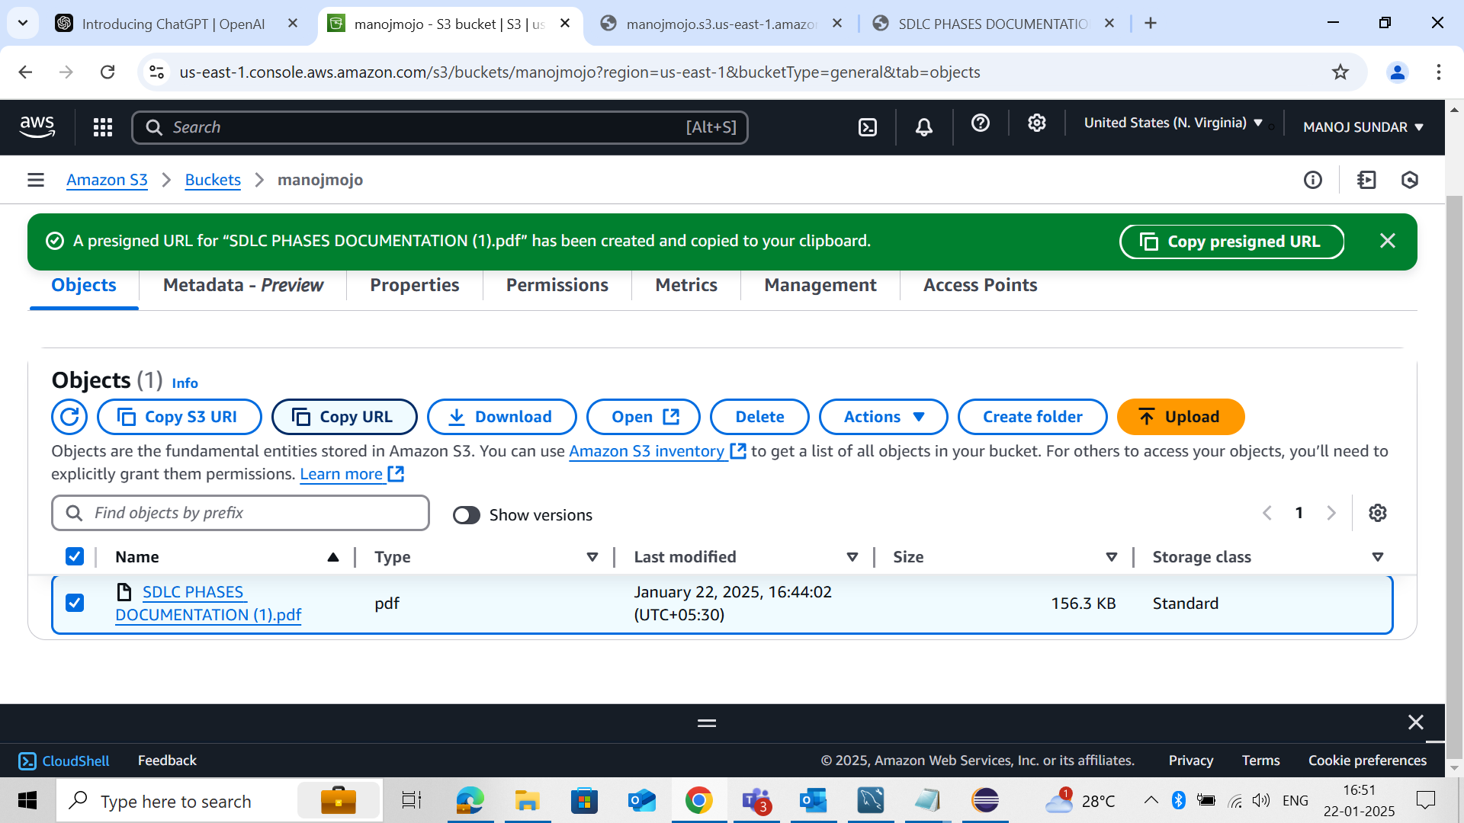

**STEP 18 : Now the File has been Open**

